AI-POWERED REAL-TIME POTHOLE DETECTION AND HAZARD RISK ASSESSMENT SYSTEM FOR MICRO-MOBILITY (BICYCLE AND ELECTRIC SCOOTER) USERS

Muhammad al ieqbal nur haqiemi bin abdul khalid

UNIVERSITI TEKNIKAL MALAYSIA MELAKA

BORANG PENGESAHAN STATUS LAPORAN

JUDUL: [AI-POWERED REAL-TIME POTHOLE DETECTION AND HAZARD RISK ASSESSMENT SYSTEM FOR MICRO-MOBILITY (BICYCLE AND ELECTRIC SCOOTER) USERS ]

SESI PENGAJIAN: [2026 / 2027]

Saya: Muhammad Al Ieqbal Nur Haqiemi bin Abdul Khalid

mengaku membenarkan tesis Projek Sarjana Muda ini disimpan di Perpustakaan Universiti Teknikal Malaysia Melaka dengan syarat-syarat kegunaan seperti berikut:

- Tesis dan projek adalah hakmilik Universiti Teknikal Malaysia Melaka.
- Perpustakaan Fakulti Kecerdasan Buatan dan Keselamatan Siber dibenarkan membuat salinan unituk tujuan pengajian sahaja.
- Perpustakaan Fakulti Kecerdasan Buatan dan Keselamatan Siber dibenarkan membuat salinan tesis ini sebagai bahan pertukaran antara institusi pengajian tinggi.
- * Sila tandakan ()

__________ | SULIT | (Mengandungi maklumat yang berdarjah keselamatan atau kepentingan Malaysia seperti yang termaktub di dalam AKTA RAHSIA RASMI 1972)
__________ | TERHAD | (Mengandungi maklumat TERHAD yang telah ditentukan oleh organisasi / badan di mana penyelidikan dijalankan)
__________ | TIDAK TERHAD

(TANDATANGAN PELAJAR) |  | (TANDATANGAN PENYELIA)
Alamat tetap: _____________________ |  | ________________________________
_________________________________ |  | Nama Penyelia
Tarikh: __________________________ |  | Tarikh: __________________________

CATATAN: * Jika tesis ini SULIT atau TERHAD, sila lampirkan surat daripada pihak berkuasa.

[TITLE OF FINAL YEAR PROJECT]

[NAME OF STUDENT]

This report is submitted in partial fulfillment of the requirements for the
Bachelor of [Computer Science (Artificial Intelligence)] with Honours.

FACULTY OF ARTIFICIAL INTELLIGENCE AND CYBER SECURITY UNIVERSITI TEKNIKAL MALAYSIA MELAKA
[YEAR OF SUBMISSION]

DECLARATION

I hereby declare that this project report entitled
[TITLE OF FINAL YEAR PROJECT]
is written by me and is my own effort and that no part has been plagiarized
without citations.

STUDENT : ______________________________________ Date : ________
([NAME OF STUDENT])

I hereby declare that I have read this project report and found
this project report is sufficient in term of the scope and quality for the award of
Bachelor of [Computer Science (Artificial Intelligence)] with Honours.

SUPERVISOR : ______________________________________ Date : ________
([NAME OF THE SUPERVISOR])

DEDICATION

[To my beloved parents...]

ACKNOWLEDGEMENTS

[I would like to thank En. Muhammad bin Ahmad for giving assistant to complete this project successfully…...

I would also like to thank my beloved parents who have been giving me support and motivation throughout my project…]

ABSTRACT

[Abstract must start from here. Abstracts should be concise, WRITTEN IN ONE SPACING and justification and NOT MORE THAN 300 WORDS IN A SINGLE PAGE. Abstract is not the same as synopsis or report summary. Abstracts are WRITTEN WITH ONE PARAGRAPH. It should briefly state the field of report studies, problems to be solved, solutions, research processes; and the results obtained.]

ABSTRAK

[Abstrak mesti bermula disini. Abstrak mestilah ringkas, DITULIS DALAM SATU LANGKAU dan justifikasi TIDAK LEBIH DARIPADA 300 PERKATAAN DALAM SATU MUKASURAT sahaja. Abstrak tidak sama dengan sinopsis atau ringkasan tesis. Abstrak DITULIS DALAM SATU PERENGGAN. Ia hendaklah menyatakan dengan ringkas bidang kajian tesis, masalah yang hendak diselesaikan, cara penyelesaian, proses penyelidikan; dan keputusan yang diperolehi.]

table of contents

PAGE

DECLARATION ii
DEDICATION iii
ACKNOWLEDGEMENTS iv
ABSTRACT v
ABSTRAK vi
table of contents vii
list of tables ix
list of figures x
List of Abbreviations xi
List of ATTACHMENTS xii
Chapter 1: INTRODUCTION 1
1.1 About Chapters and First Subtitle 1
1.1.1 Second Subtitles 2
1.1.1.1 Third Subtitles 2
Chapter 2: literature review AND PROJECT METHODOLOGY 3
2.1 About Figures 3
Chapter 3: REQUIREMENT ANALYSIS 5
3.1 About Tables 5
Chapter 4: DESIGN 7
4.1 About Table of Content 7
Chapter 5: RESULTS AND DISCUSSION 9
5.1 About List of Tables 9
5.2 About List of Figures 9
5.3 About List of Figures 9
5.4 About List of Figures 9
5.5 About List of Figures 10
Chapter 6: CONCLUSION 11
6.1 Wrap-Up 11
references 12
APPENDICES 13

list of tables

PAGE

Table 3.1: Table Example 5

list of figures

PAGE

Figure 2.1: Caption Window 3
Figure 2.2: Caption Numbering Window 4
Figure 2.3: Example Figure with citation from a book (Pike, 2008. Used with permission) 4
Figure 4.1: How to update Table of Contents in this template 7
Figure 4.2: Updating the whole list 7

List of Abbreviations

FYP | - | Final Year Project

List of ATTACHMENTS

 |  |  | PAGE
Appendix A |  | Sample of data | 19
Appendix B |  | Analysis of data collection | 78
…….. |  | …………
…….. |  | …………

Abstract

Micro-mobility solutions, particularly bicycles and electric stand-up scooters have become integral components of modern urban transit systems. While these transport modes offer significant environmental benefits and address first and last mile logistics, their safety is routinely compromised by decaying road infrastructure. Potholes and other surface anomalies pose severe risks to micro-mobility riders due to the vehicle’s small wheel diameters and rigid suspension geometries. Standard vehicular safety technologies are designed for passenger cars and do not cater to these vulnerable road users, while existing mapping applications lack the real-time, localized hazard warnings necessary to prevent accidents. Furthermore, accelerometer-based detection methods are reactive, registering road anomalies only after an impact has occurred. To address these safety gaps, this paper proposes a proactive, vision-based road hazard detection and risk assessment system designed to run locally on handlebar-mounted mobile devices. I have utilized a lightweight YOLOv8 Nano object detection model optimized for edge execution via TensorFlow Lite with INT8 quantization, operating fully offline to ensure zero latency and protect user privacy. To mitigate alert fatigue, we formulate a dynamic, physics-inspired Risk Assessment Algorithm that calculates a Risk Index by correlating the detected pothole's dimensions with the vehicle's instantaneous GPS speed and wheel diameter. This paper details the system's architecture, including a concurrent execution model using background isolates to prevent UI lag. Our implementation achieves real-time inference at over 15 Frames Per Second on standard mobile processors with a pipeline latency under 200 ms, successfully warning riders of high-risk hazards through high-contrast visual overlays and audio alerts.

Introduction

Introduction
The rapid expansion of urban centers has triggered a corresponding rise in micro-mobility solutions, notably electric scooters and bicycles, which offer clean, efficient, and flexible alternatives to traditional vehicular transit. However, urban road infrastructure has failed to evolve alongside these micro-mobility networks. Surface defects, such as potholes, present a severe hazard to light, two-wheeled vehicles. Unlike passenger automobiles, which feature large pneumatic tires and complex suspension systems capable of absorbing significant impacts, micro-mobility vehicles generally have small wheel diameters and rigid frames. A minor asphalt depression that causes a negligible bounce in a car can destabilize a scooter or bicycle, leading to catastrophic accidents, severe rider injuries, or structural frame failures.

To address this issue, modern safety technology must shift from reactive monitoring to proactive prevention. Traditional GPS applications provide route guidance but fail to offer granular, real-time hazard warnings. Similarly, standard dashboard cameras only document accidents post-occurrence. A real-time, vision-based hazard detection system mounted directly on the vehicle handlebars is required to identify road defects before a collision occurs and assess threat severity based on the rider's immediate velocity and vehicle constraints.

Problem Statement
The safety framework for micro-mobility users suffers from three critical vulnerabilities. First, the mechanical design of bicycles and electric scooters specifically their small wheels and lack of substantial suspension renders riders highly susceptible to minor road defects, where hitting a standard-sized pothole often results in a loss of control or a front-wheel lockup. Second, contemporary navigation platforms, such as Google Maps or OpenStreetMap, provide static route suggestions but lack real-time, crowdsourced, or localized surface quality assessments, leaving riders unaware of immediate road degradation. Third, current vehicle safety systems are primarily reactive, which record impact data or register GPS coordinates after an accident has occurred, failing to deliver immediate, contextual warnings that allow the rider to execute safe evasive maneuvers before reaching the hazard.

Objectives of the Project
To resolve these challenges, the project has established three primary research objectives. The first objective is to study, train and optimize a lightweight convolutional neural network utilizing the YOLOv8 architecture to achieve real-time, vision-based pothole detection on resource-constrained mobile hardware. The second objective is to design and develop a fully offline Android application in Flutter that integrates camera feed processing, real-time GPS speed measurements and an exponential speed-risk calculation algorithm to deliver visual and audio alerts to the rider. The third objective is to systematically evaluate the trade-offs between three different model scales which are YOLOv8 Nano, YOLOv8 Small and YOLOv8 Medium and will be quantified through training latency, Mean Average Precision, post-quantization model size and on-device inference speed.

Scope of the Project
The scope of this project is strictly defined across data, hardware and software parameters. Geographically and operationally, the system is designed for handlebar-mounted Android smartphones deployed on bicycles or electric scooters, processing camera feeds in a forward-facing orientation. The data scope is restricted to the Pothole-vhmow dataset sourced from Roboflow Universe, compiled and pre-processed to target pothole defects under variable daylight, shadowing, and viewing angles. Software execution is constrained to a fully offline environment, executing inference locally on the device CPU using 8-bit quantized TensorFlow Lite (TFLite) models, which ensures zero latency and constant protection of user location privacy without requiring cellular connectivity.

Project Significant
This research provides dual-fold contributions to individual safety and urban planning. For micro-mobility riders, the proactive warning system directly mitigates the risk of accidents by providing a visual HUD overlay and high-frequency audio beeps when approaching a pothole at unsafe speeds. For municipalities and the broader public, the application archives ride telemetry and detected hazard coordinates locally, establishing a foundation for aggregate local mapping that can inform road maintenance crews of critical defects, improving overall urban infrastructure safety.

Expected Output
The project outputs consist of two core components. The first is a set of optimized, INT8-quantized YOLOv8 object detection models exported to the TFLite format. The second is a fully functional Android mobile application built using the Flutter framework. This application features a real-time recording HUD, a dynamic sound synthesis module for contextual audio warnings and an offline history map interface utilizing OpenStreetMap tiles rendered via a custom dark-theme filter matrix to plot historical commute coordinates and hazard pins.

Report Organisation
This report is divided into six chapters. Chapter 1 introduces the project background, objectives, scope, and significance. Chapter 2 details the literature review, analysing existing road damage detection systems and presents the project methodology. Chapter 3 outlines the requirement analysis, specifying the functional, non-functional, and data demands. Chapter 4 describes the high-level and low-level architectural design of the application. Chapter 5 compiles the experimental results, comparing the trained YOLOv8 Nano, Small, and Medium models and validating the dynamic risk index. Finally, Chapter 6 summarizes the research findings and proposes recommendations for future work.

Summary
In summary, this chapter established the foundation of the research by highlighting the physical vulnerabilities of micro-mobility users to road defects and outlining the proposed vision-based solution. The objectives, scope, and expected outputs were defined to focus the development on a real-time, offline Android application. The next chapter will provide an analysis of existing literature and detail the methodology used to train the models and implement the software.

Literature Review and project methodology

Introduction
Developing a real-time, on-device road hazard detection system requires a synthesis of computer vision, mobile software engineering, and spatial data modelling. This chapter reviews the physical challenges within the micro-mobility domain, evaluates existing detection systems, compares standard deep learning models, and details the project methodology and technical requirements.

Facts and Findings

Domain
Micro-mobility vehicles, comprising bicycles and electric scooters are physically distinct from passenger vehicles. Their key constraint is the wheel-to-hazard diameter ratio. A standard electric scooter utilizes tires between 8.5 and 10 inches in diameter, whereas a standard passenger car tire exceeds 26 inches. Consequently, a pothole with a depth of 2 inches presents a minor nuisance to a car but represents a major obstacle to a scooter, equal to roughly 20% of its tire diameter. Additionally, these lightweight vehicles lack passive damping systems, transferring the kinetic energy of an impact directly to the handlebars and the rider. This mechanical vulnerability necessitates proactive detection, allowing the rider to circumvent the defect rather than relying on impact mitigation.

Existing System
Existing road hazard mapping systems fall into three categories: tactile/vibration-based, active range-finding, and visual inspection. Tactile systems utilize smartphone accelerometers to log anomalies. While computationally cheap, they are inherently reactive, registering the hazard only after the vehicle has experienced the impact. Active range-finding systems using LiDAR provide high accuracy but are cost-prohibitive and consume substantial power, making them unsuitable for consumer mobile deployment. Visual inspection systems are typically deployed on municipal vehicles using high-definition cameras and cloud processing, which lacks real-time warning capabilities for individual riders.
Parameters | Accelerometer System | LiDAR Systems | Municipal Survey | Proposed App
Detection Type | Reactive (post-impact) | Proactive (pre-impact) | Proactive | Proactive (pre-impact)
Cost | Low (Built-in sensor) | Very High (LiDAR unit) | High (Specialized vehicle) | Low (Standard smartphone)
Edge Processing | Offline | Offline/ Local | Offline/ Upload | Offline (Local TFLite)
Warning Latency | N/A (No warning) | Medium | N/A (Offline report) | Very Low (<200ms)
Network Dependency | Low | Low | High | None (Fully Offline)
Table 2.1: Comparison of Existing Hazard Detection Systems

Technique
Real-time visual object detection on mobile hardware requires models with low parameter counts fast inference speeds and high representation capacity. Traditional two-stage detectors, such as Faster R-CNN, achieve high accuracy but have excessive inference latencies that prevent real-time mobile deployment. One-stage detectors, such as SSD MobileNet and the YOLO series, consolidate bounding box regression and classification into a single pass. YOLOv8 optimizes this approach by employing an anchor-free detection head and a decoupled structure, separating classification and regression branches to maximize mean Average Precision (mAP) while minimizing computational complexity.
Architecture | Parameter Count | GPU Latency | mAP50 | Edge Suitability
Faster R-CNN | ~40M | High | ~82% | Poor (Too heavy)
SSD MobileNetV2 | ~3.4M | Very Low | ~70% | High (Low accuracy)
YOLOv8 Nano | ~3.2M | Very Low | ~89% | Excellent
YOLOv8 Small | ~11.2M | Low | ~92% | High
YOLOv8 Medium | ~25.9M | Medium | ~94% | Medium
Table 2.2: Comparison of Object Detection Architectures

Project Methodology
This project adopts a structured methodology based on the CRISP-DM (Cross-Industry Standard Process for Data Mining) framework, adapted for deep learning deployment. The methodology is divided into three distinct phases.
Phase 1: Data Acquisition and Pre-processing. The Pothole-vhmow dataset (v18), consisting of 1,302 pothole images, was sourced from Roboflow Universe. Using the Roboflow API, the dataset was pre-processed to target pothole defects. Pre-processing steps included auto-orientation of pixel data, EXIF-orientation stripping, and resizing to 640x640 pixels. The final dataset was split into training, validation, and testing partitions.
Phase 2: Model Training and Quantization. Three scales of YOLOv8 (Nano, Small, and Medium) were trained for 50 epochs with an input size of 320x320 pixels using PyTorch on a local workstation. Following training, the models were converted to the TensorFlow SavedModel format and subjected to INT8 Post-Training Quantization (PTQ). This quantization maps the 32-bit floating-point weights and activations to 8-bit integers using a representative dataset of 100 images to calibrate dynamic ranges.
Phase 3: Android Integration. The quantized `.tflite` models were integrated into the Flutter application. Using the TFLite Interpreter API, the app passes camera frames directly to the model, parses the output bounding boxes and calculates coordinates relative to the screen size. GPS telemetry is captured via the Geolocator package, and both telemetry and detections are processed by the alert logic.

Project Requirements

Software Requirements
The development stack comprises:
- Flutter SDK (Dart) for cross-platform UI construction and hardware bindings.
- PyTorch and the Ultralytics API for training YOLOv8 architectures.
- TensorFlow Lite (TFLite) library for mobile compilation and quantization.
- Android SDK (API Level 21+) for compiling the final application.
- VS Code and Android Studio as the integrated development environments.

Hardware Requirements
The hardware environment includes:
- Workstation equipped with an NVIDIA GeForce RTX 3050 Laptop GPU (4GB VRAM) for CUDA-accelerated model training.
- Android smartphone (test device: Xiaomi 22101316UG, 8GB RAM, octa-core CPU) for deploying and validating the mobile application.

Project Schedule and Milestones
The project is executed over two academic semesters. The first semester focuses on proposal validation, data collection, literature synthesis and preliminary model testing. The second semester focuses on workstation-based GPU model training, edge quantization, Flutter application development, local storage persistence implementation, field testing, and report compilation.

Summary
This chapter analyzed the mechanical constraints of micro-mobility, justified the use of YOLOv8 and TFLite through comparative analysis, and detailed the CRISP-DM methodology. The hardware and software requirements were defined to establish a clear development boundary. The next chapter will detail the requirement analysis, mapping the operational requirements of the system.

PROJECT Methodology

Introduction
Before designing the application components, the system's requirements must be modelled to align with physical safety constraints and the smartphone's hardware limits. This chapter provides a problem analysis, defines the mathematical alert logic, and details the data, functional, and non-functional requirements.

Problem Analysis
Under normal riding conditions, a cyclist or scooter rider relies on manual visual scanning. This process becomes unreliable under high speeds, direct sunlight, or fatigue. If a rider fails to notice a pothole, the collision occurs without warning, transferring impact energy to the vehicle frame. The proposed system acts as an active safety layer. It continuously captures video frames and GPS speed, performs on-device object detection, and runs a Risk Assessment Algorithm. If the computed Risk Index exceeds a critical threshold, the system delivers immediate visual and audible feedback, enabling the rider to adjust their course.
The threat severity of a pothole is mathematically modeled by the Risk Index (RI) formula:
$$RI = \left(\frac{S_{detected}}{S_{threshold}}\right)×{\left(\frac{V_{current}}{V_{limit}}\right)}^{2}× 100\%$$
Where the parameters are defined as:
- $S_{detected}$: The surface area of the bounding box generated by the YOLOv8 model in pixels.
- $S_{threshold}$: The wheel size calibration constant. If E-scooter is selected, a smaller constant is used. (e.g. 8.5 Inches), which increases the baseline risk score. If Bicycle is selected (26 inches), a larger constant is used, which dampens the risk.
- $V_{current}$: The real-time velocity retrieved from the smartphone's GPS receiver in km/h.
- $V_{limit}$: The speed limit constant (default: 25 km/h)
By squaring the velocity ratio, the formula mirrors the kinetic energy equation $(K.E. = \frac{1}{2}{mv}^{2})$. This design ensures that the calculated risk scales exponentially with speed, recognizing that hitting a pothole at 20 km/h is four times more destructive than hitting the same pothole at 10 km/h.

System Workflow Flowchart
This flowchart represents the real-time processing loop during a commute session:
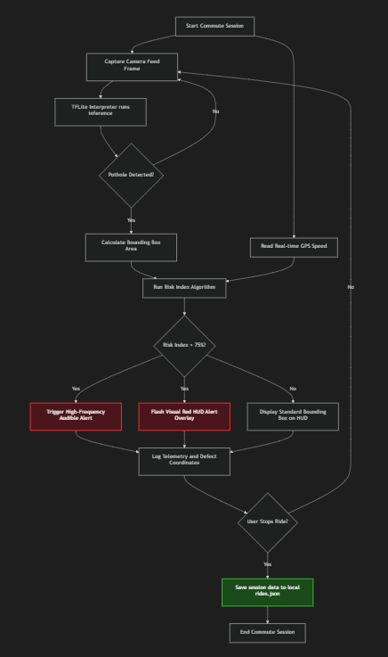

Requirement Analysis

Data Requirements
The system requires three primary data inputs: camera frame buffers (converted to RGB image arrays), GPS latitude/longitude coordinates, and speed values (m/s converted to km/h).
For persistence, the application utilizes two local JSON files:
- rides.json: Stores historical ride records. The schema includes a unique ride ID, date/time stamp, total distance, duration, average speed, a list of polyline coordinate pairs representing the route, and a list of logged pothole markers containing latitude, longitude, and computed Risk Index.
- settings.json: Stores user configurations, including vehicle type selection (E-Scooter or Bicycle), alert volume level, speed simulation toggle, and simulated target speed.

Local Data Schemas Reference Tables
These tables show the exact data fields managed by the database layer:
Field Name | Data Type | Description
id | String | Unique UUID for the commute session.
title | String | Time-of-day formatted name (e.g., "Morning Ride ").
date | String | ISO-8601 formatted timestamp of the ride.
distance | Float | Total ride distance completed (in km).
duration | Integer | Total commute length (in seconds).
avgSpeed | Float | Calculated average velocity (in km/h).
maxSpeed | Float | Highest recorded velocity (in km/h).
polyline | Array of lists | Array of [latitude, longitude] tracking the route path.
potholes | Array of objects | List of hazards logged, containing coordinates and Risk Index.
Table 3.1: Ride History Data Schema (rides.json)

Field Name | Data Type | Description
vehicleType | String | Toggle value: "E-Scooter" or "Bicycle".
alertVolume | Float | Range of 0.0 (mute) to 1.0 (maximum beep volume).
simulateSpeed | Boolean | True enables GPS speed override simulation for testing.
targetSpeed | Float | Target cruise speed (in km/h) for the simulation slider.
Table 3.2: Application Settings Schema (setting.json)

Functional Requirements
The application must perform the following core functions:
- Camera Stream Capture: Retrieve frames from the device camera and stream them to the TFLite Interpreter.
- Local Inference: Run the TFLite model locally to detect potholes, producing class labels, confidence scores, and bounding boxes.
- GPS Telemetry Processing: Monitor the device GPS, calculate vehicle speed, and append coordinates to the active route polyline.
- Dynamic Alerting: Compute the Risk Index using the active speed and model detections, triggering a visual red screen flash and synthetic audio beeps if the risk exceeds 75%.
- Session Persistence: Record the commute path and logged hazard locations to local storage when the user taps "Save Ride."
- Route Rendering: Load historical routes and render them on a dynamic map with color-coded hazard markers (green for low risk, orange for medium, red for high).

Functional Use Case Diagram
This diagram maps rider actions to functional subsystems:
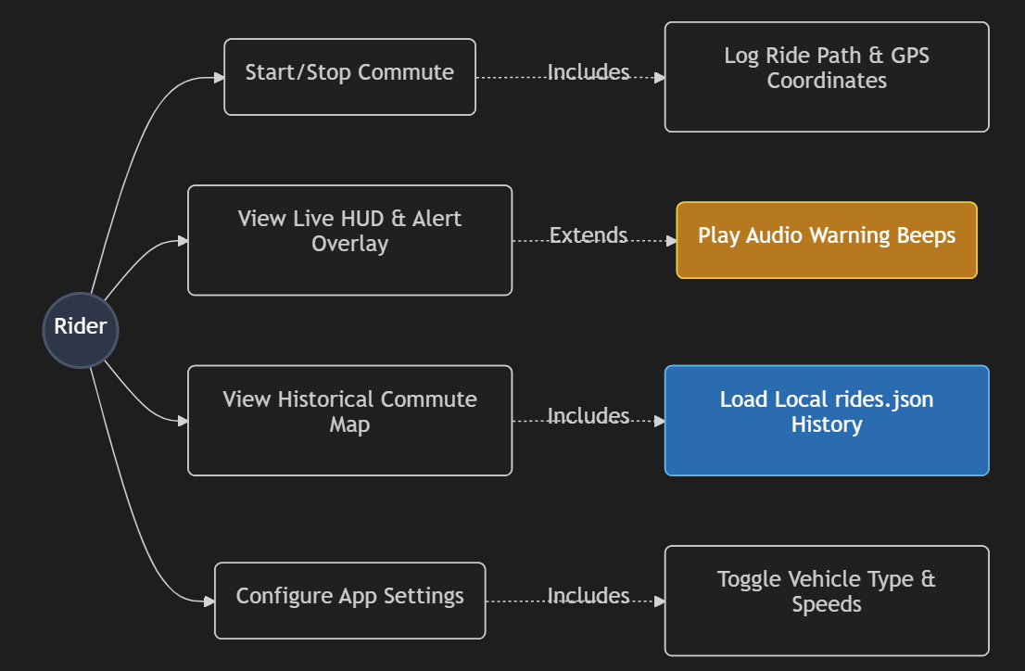

Non-Functional Requirements
The system must satisfy several performance and operational constraints:
- Latency: The combined latency of image capture, model inference and risk computation must remain below 200 milliseconds to provide a warning before the vehicle reaches the defect.
- Offline Capability: The core detection, alert and persistence logic must function entirely without internet connectivity, relying on local resources.
- Sunlight Readability: The user interface must employ a high-contrast dark theme to ensure HUD metrics and map lines remain legible under direct sunlight.
- Resource Optimization: The application must release camera and GPS resources immediately upon stopping a recording to conserve device battery.

Others Requirement
The selection of Flutter and TFLite is justified by cross-platform compatibility and edge performance. Flutter allows native compilation on Android with access to low-level hardware APIs (Camera, Location) without intermediate bridges. TensorFlow Lite provides specialized hardware acceleration via the Android Neural Networks API (NNAPI), enabling the model to utilize the device NPU or GPU for faster inference.

Summary
This chapter analyzed the requirements of the pothole detection application. The dynamic Risk Index formula was defined to scale threat levels with vehicle velocity, and the data, functional, and non-functional requirements were established. The next chapter will present the system's structural and interface designs.

Proposed Method

Introduction
This chapter presents the architectural and component designs of the AI-powered real-time pothole detection and hazard risk assessment system. It defines the structural layout of the application, starting from the high-level system architecture down to the detailed low-level designs. The chapter covers the three-tier system architecture, user interface design (including input, output, and navigation flows) non-database data serialization schemas, and the deep learning component design (focusing on the YOLOv8 network configuration and the mobile TFLite execution logic).

High-Level Design

System Architecture
The application is structured using a three-tier architectural pattern, which isolates core visual elements from processing logic and data persistence. This modularity ensures that camera frames and GPS signals are processed asynchronously without blocking the user interface thread.

The diagram below visualizes the architectural layout:
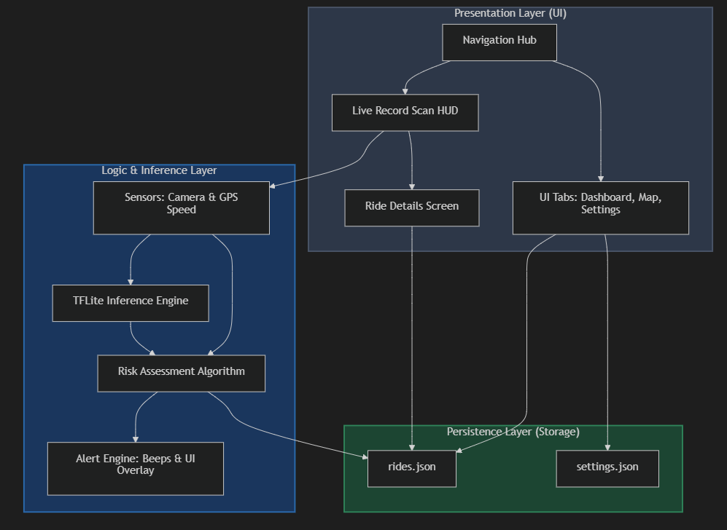

System Sequence Diagram
This diagram shows the sequence of operations between subsystems when a riding commute is active:
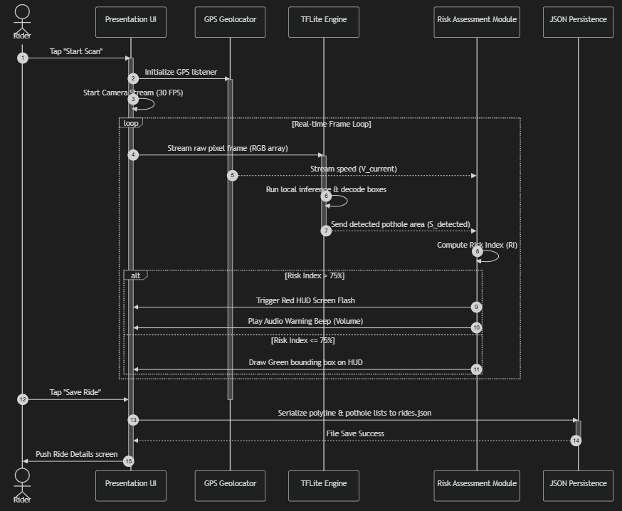

User Interface Design
The user interface is designed as a dark-theme dashboard structured around four core navigation tabs, optimized for high visibility under direct sunlight on handlebar mounts.
- Navigation Flow Design
The diagram below maps the navigation path of the user through the application:
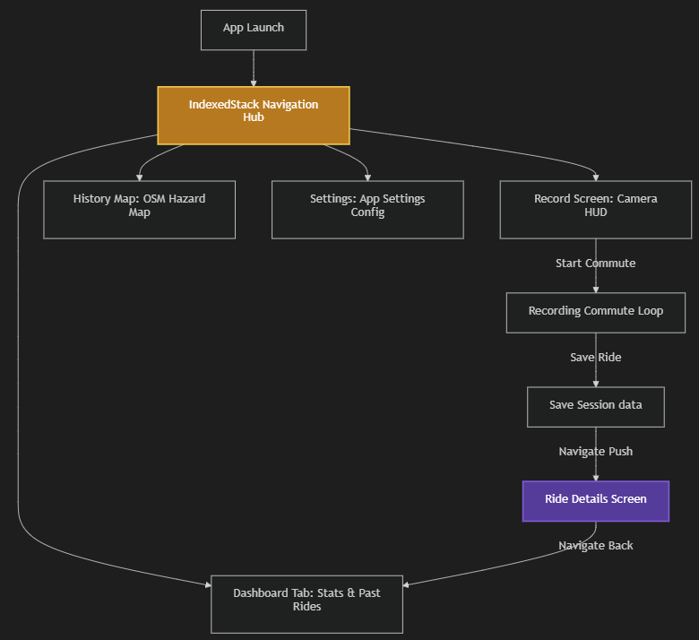

- Input Design
System inputs are divided into hardware sensor feeds and user configurations.
- Sensor inputs include the raw 30 FPS camera frames and GPS coordinate streams.
- User inputs include the vehicle type selector (toggling between E-Scooter and Bicycle settings), the alert volume slider (0.0 to 1.0), the speed simulation toggle, and the target speed simulation slider (10 to 40 km/h).
- Validation rules require camera and location permissions to be granted before starting a ride. If permission is denied, the start button is disabled, and an error prompt is displayed. The simulated speed input is clamped to a maximum of 40 km/h to prevent out-of-bounds calculations in the risk algorithm.

- Output Design
System outputs are designed to be immediate and non-intrusive.
- Visual Outputs: A bounding box drawn around the pothole with a label (e.g., "Pothole: 88%") is rendered on the HUD. If the Risk Index exceeds 75%, a semi-transparent red overlay flashes across the screen. On the map views, route paths are plotted as a blue polyline, and hazard locations are displayed as color-coded pins.
- Audio Outputs: Synthetic warnings play at variable frequencies; the beep frequency scales with the risk index, alerting the rider to slow down as their velocity increases.
- Tabular Statistics: Total distance (km), ride duration (seconds), average speed (km/h), and logged pothole counts are rendered in tables on the Dashboard feed and the Details screen.
Rider Dashboard Interface
Pre-Recording Landing Screen
Active Scanning HUD with Detections
Aggregate Hazard Map
Ride Details and Polyline Summary
//GAMBAR (5)

AI Component Design

YOLOv8 Model Configuration
The model uses a CSPDarknet53 backbone coupled with a Spatial Pyramid Pooling Fast (SPPF) layer to extract multi-scale features from input frames. A Path Aggregation Network (PANet) path acts as the model neck, fusing features from different resolution layers. The detection head is an anchor-free decoupled structure. Instead of predicting offsets from predefined anchor boxes, it directly predicts the bounding box boundaries and class probability for potholes, reducing the overall model parameter count and accelerating inference.

TFLite Execution Flow
During runtime, raw camera frames (normally 1280x720 pixels) are captured and resized via a pre-processing pipeline to a shape of 320x320x3 pixels. The pixel values are normalized to a range of 0.0 to 1.0. The pre-processed tensor is passed to the TFLite Interpreter. The output tensor, representing bounding box coordinates and confidence scores is parsed using a confidence threshold of 0.25 and a Non-Maximum Suppression (NMS) threshold of 0.45 to eliminate overlapping boxes. The bounding box area of the remaining detections is passed to the Risk Assessment Algorithm.

Software Design
The mobile software is organized around a set of modular Dart classes:
- RideHistoryService: Manages file I/O operations, reading and writing the rides.json file to local app directories.
- AppSettingsService: Persists configuration selections (vehicle type, volume, and simulation parameters) to settings.json.
- HomeScreen: Coordinates camera controller initialization, listens to GPS geolocator streams, performs real-time frame pre-processing, feeds the TFLite interpreter and computes the dynamic Risk Index.
- DashboardTab: Displays global rider statistics and queries about the history service to render a scrollable feed of previous commutes.
- HistoryMapTab: Loads previous commutes, extracts all hazard coordinate points and renders them as colored markers on OpenStreetMap using a custom dark-theme color filter.

Summary
This chapter detailed the structural and component designs of the application, modeling the three-tier architecture, user interface inputs/outputs, non-database data serialization, and the YOLOv8 TFLite model configuration. The next chapter will present the experimental results, comparing the performance metrics of the trained YOLOv8 Nano, Small and Medium models.

Concurrency and Isolate Communication Design

Result

Wrap-Up
Please enjoy writing your FYP

references

Buchwalow, I. B., and Böcker, W. (2010). Immunohistochemistry: basics and methods. Berlin: Springer Verlag.

Caamaño-Tubío, R. I., Pérez, J., Ferreiro, S., and Aldegunde, M. (2007). Peripheral serotonin dynamics in the rainbow trout (Oncorhynchus mykiss) Comparative Biochemistry and Physiology Part C: Toxicology & Pharmacology. 145(2): 245-255.

Cameron, A. A., Plenderleith, M. B. and Snow, P. J. (1990). Organization of the spinal cord in four species of elasmobranch fishes: cytoarchitecture and distribution of serotonin and selected neuropeptides. The Journal of Comparative Neurology. 297: 201-218.

Desa, M.I (1995). Bus fleet maintenance modeling in a developing country. Ph.D Thesis, University of Salford.

Improve indigenous housing now, government told, 2007. accessed 8 February 2009, <http://www.architecture.com.au/i-cms?page=10220>.

International Narcotics Control Board 1999, United Nations, accessed 1 October 1999, <http://www.incb.org>.

Theusen, G. J. and Fabrycky, W. J. (1984). Engineering Economy. 6th. Ed. Englewood Cliffs, N. J.: Prentice Hall. 150-178.

APPENDICES

